Week 8 of ENL Distant Learning Lessons May 25 – May 29, 2020

Monday May 25, 2020

Objectives: I can write and debate using text evidence.

Does Lulu Need a Phone?

She says she’s ready for one. Her older sister isn’t so sure. What do you think?

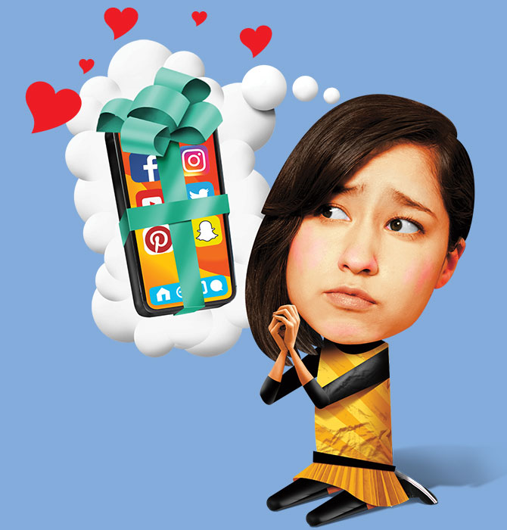

*Dear Katie,*

    My 12th birthday is next month, and there’s only one thing I want: a smartphone. All of my friends have one. Dad says I have to wait until high school. But with your help, I think I can change his mind.

    Because I don’t have a phone, I get left out. My friends have a group text, and they send Snapchats back and forth. It’s like there’s a whole world I’m not a part of.

    Dad says I should just hang out with my friends in person. Well, sometimes I don’t get invited because the plans are made in the group text! A phone would change that. Plus, it would make things easier for the whole family. How many times have you all had to call my friends to get in touch with me?

    You know I’m responsible. I never lose anything. With you on my side, Dad might get me a phone. Will you help me?

*Love,  
Lulu, your little sister*



Illustration by John Corbitt

*Dear Lulu,*

    This might surprise you, but I’m with Dad. He had the same rule for me. And now that I’ve had my phone for a year, I get it.

    In health class, we’ve been learning about how our phones change us. We’ve learned that kids who spend a lot of time on their phones get lower test scores and worse sleep. I know that’s true. Last year, I failed two big tests because I was up late on TikTok.

    I feel like I have no control when it comes to my phone. I’m always checking it. I can’t seem to put it down.

    In middle school, I spent much more time reading and playing the guitar. I saw my friends more too. I miss that! So try to enjoy your last years without a phone. They’ll go by fast, I promise.

*Love,  
Katie, your older sister*

**Directions**: From the reading, provide evidence from ***both*** sides of the argument of whether or not Lulu needs a phone. Write your answers below.

1. Does Lulu need a phone? Yes, a phone would make her life easier.

A.

B.

C.

1. Does Lulu need a phone? No, it is better to wait until she is older and more mature.

A.

B.

C.

1. If you were Lulu’s older sister, what advice would you give her?
2. What kind of tone is Katie’s letter to letter?

Tuesday and Wednesday May 26 – May 27, 2020

Objective: I can compare and contrast two nonfiction articles.

Superman Becomes a Superstar

The surprising story behind the world’s first superhero

It was 1938, and Americans were in trouble. Millions of people had lost their jobs. Hundreds of thousands were homeless. It had been like this for nearly 10 years, and there was no end in sight.

    But wait! *Up in the sky! It’s a bird! It’s a plane!* It’s—the world’s first superhero.

    That’s right. Superman first appeared in comic books in April 1938. The country was in the middle of a long [**economic**](javascript:void(0);) crisis called the Great Depression. Americans needed an escape from their problems. They needed a hero who fought for the poor and the powerless.

    Superman was their champion. And this is his real [**origin**](javascript:void(0);) story.

**In The Beginning**

Superman was invented by nerds. That’s how Jerry Siegel and Joe Shuster would have described themselves. They went to high school together in Cleveland, Ohio.

    Siegel wrote the first Superman pages. Shuster drew them. They gave their hero a [**disguise**](javascript:void(0);)—as a newspaper reporter named Clark Kent. He would be quiet and gentle “like Joe and I are,” Siegel said. But as Superman, he would fight for anyone who felt powerless.

**The People’s Hero**

In the 1930s, many people felt powerless. During the Great Depression, one in four Americans lost their jobs. Millions left their homes to find work. They stood in long lines to get free food.

    Many Americans felt angry about the problems they faced. They blamed the rich and powerful. They blamed bankers, factory owners, and dishonest [**politicians**](javascript:void(0);). These were Superman’s enemies too.

    In the early comic books, Superman fought evil businessmen. He went after a mine owner who had put his workers in danger. Superman also battled a carmaker who made unsafe cars.

    Years later, Superman would fight mad scientists who wanted to destroy Earth. But at first, he saved people from real-world villains.

**Rise of Comics**

Superman helped Americans. He also helped comic book companies. Five years before Superman, comics were only printed in newspapers. After his arrival, 10-cent comic books flew off the shelves. Each Superman issue sold 1.3 million copies.

    The biggest comic book companies created many superheroes. DC Comics was one company. It had Green Lantern. He beat up on evil bankers. Batman was another DC hero. He fought criminals in Gotham City. Marvel was another company. It had Captain America, the Sub-Mariner, the Human Torch, and more.

    After Superman arrived, 9 in 10 kids read comic books. A lot of adults did too.

**Unhappy Ending**

Siegel and Shuster invented the superhero. They also made a fortune for DC Comics.

    But Siegel and Shuster never got rich. They had sold Superman to DC. They got paid just $5 a page.

    A big company took advantage of two ordinary guys.

    Now that sounds like a job for Superman.

Superheroes Take Over the World

They’re everywhere these days. But . . . why?

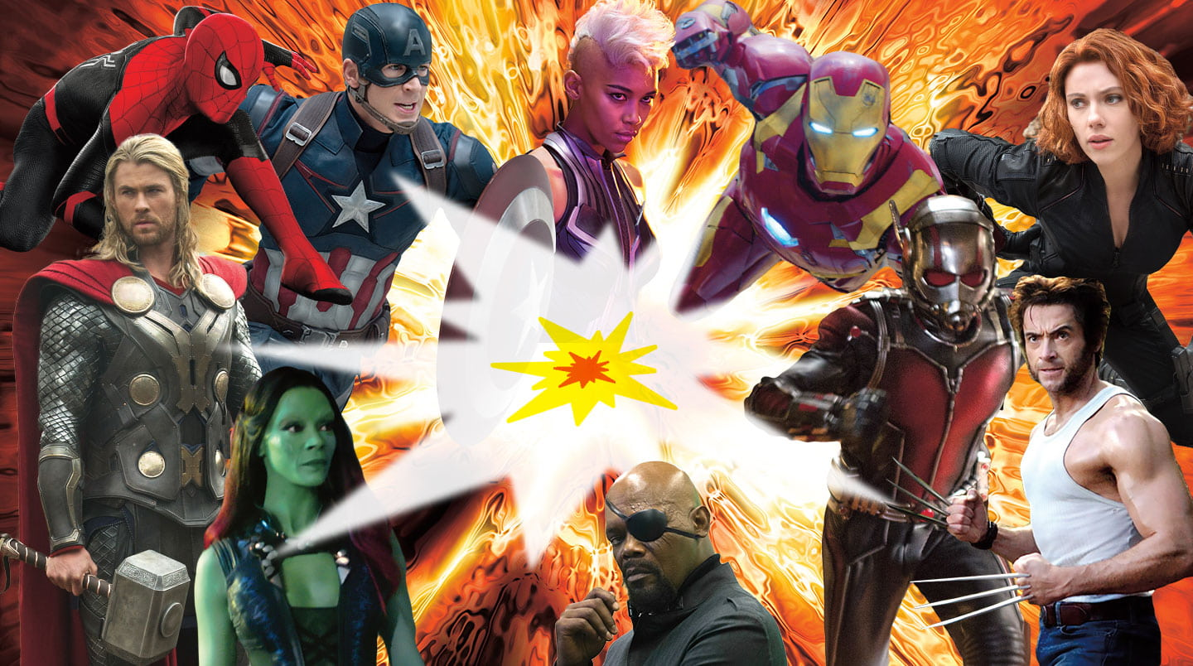

    Our world has big problems. There’s war. There’s disease. There’s climate change. It’s easy to feel powerless.

    But in the movies, one superhero can save the planet. Wonder Woman can end a war by killing a god. The Avengers can travel through time to save half the universe.

    The world loves superheroes. Last year, fans spent more than $6 billion going to superhero movies. And why not? As you eat your popcorn, you leave reality. You enter a fantasy world. And good always wins against evil.

    But there’s another reason we love superheroes. They are who we want to be. We watch Clark Kent become Superman. It reminds us that ordinary people can do great things. We watch T’Challa fight for his throne in *Black Panther.* It makes us feel brave. We believe we can make a difference in our school or stand up to bullying.

    These characters help us to be our best selves. They make us want to do what’s right.

    Now let’s pretend that the head of DC Comics just called. He wants you to create a new superhero. Who will that superhero be? What will he or she fight against?

    Answer those questions. Your answers might tell you just as much about yourself as they do about your superhero.

**Directions:** Define the following words from the articles about superheroes.

1. Disguise-
2. Politician-
3. Economic-
4. Took advantage of-
5. Origin-

**Directions**: Use one of the vocabulary words to fill in the banks of the following sentences.

1. The Great Depression was a long _______________ crisis.

2. Superman was created in 1938, and his ________________ story is very interesting.

3. A simple ________________ allowed Superman to live a normal life when he wasn’t fighting crime.

4. Angry Americans blamed powerful people, like bankers and ___________________, for the Great Depression.

5. A big comic book company ___________________ Superman’s creators and paid them very little.

Directions: Circle or highlight the correct answer for each question.

1. Superman was created ______.

A at the movies

B during the Great Depression

C before newspapers existed

D during a high school basketball game

1. At first, Superman fought ______.

A mad scientists

B climate change

C real-life villains

D newspaper reporters

1. Which of the following would be most useful as part of a disguise?

A an apple

B a pencil

C a pack of gum

D a wig

1. Which section tells you how much Superman’s creators were paid?

A “In the Beginning”

B “The People’s Hero”

C “Rise of Comics”

D “Unhappy Ending”

1. Based on the second article, watching T’Challa fight for his throne makes us feel ______.

A nervous

B brae

C powerless

D beautiful

1. Both articles tell you how ______.

A comic books are made

B you can find a good comic book

C movies are made

D superheroes can make us feel better about problems

Directions: answer the following constructed response questions in a paragraph of 3-4 sentences.

1. Why did comic book companies create many superheroes after Superman?

Thursday and Friday May 28 – 29, 2020

Objective: I can write a paragraph about nonfiction text.

Is This Ghost Town Cursed?

Visitors to Bodie, California, claim that a few stolen items are destroying their lives.

[APRIL 2020](https://action.scholastic.com/issues/2019-20/040120.html)

 Take a walk through Bodie, California, and you might wonder: Is this place haunted?

    It’s easy to imagine the ghosts of the people who used to live there. You can picture them inside the crumbling houses and hotels.

    But legend has it that Bodie isn’t just haunted. It’s cursed. It’s said that if you take anything from the town—a rusty nail, a broken dish—you’ll soon have very bad luck.

**Gold Rush Riches**

Gold Rush Riches

    In 1859, gold was discovered in a distant area in California. People rushed there, hoping to get rich. This place was named Bodie. It became a town of 10,000 people.

    Bodie was a tough place to be, though. Summers were hot. Winters were harsh. Crime was a big problem. So people left when the gold ran out. Bodie became a ghost town—an abandoned town where no one lives.

    Today Bodie is a state park. About 200,000 people visit there each year. Many decide to grab a souvenir. Bad idea! Taking anything from the park is a crime. But there’s another reason to leave Bodie as you find it. Taking a treasure—even a tiny one—just might ruin your life.

**Terrible Misfortune**

Every year, dozens of people send back things they’ve removed from Bodie. Many include letters that tell of their bad luck. Some say they got sick or lost their jobs. Kids claim to have failed tests or had their pets die.

    In truth, these bits of bad luck have nothing to do with Bodie. Park rangers made the curse up. They wanted to stop people from taking things from this important historical site.

    So what do you think? Did it work? If you visit Bodie, will you take something?

    Maybe it’s better to be safe than sorry. You can buy a T-shirt to remember your trip instead.

**Directions**: Write a paragraph below to answer the question “Why do people think Brodie is cursed?” The paragraph should have five sentences! These five sentences should include main idea sentence, three details from the article, and a conclusion sentence.